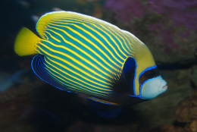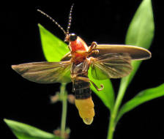

**Additional Information**

**PE**

Please ensure that PE kits are in school for the entire half term. Kits and bags should be clearly labelled with your child’s name.

**Warm Weather**

The weather will hopefully start to get warmer soon, but is still unpredictable. Please ensure your child has a lightweight raincoat for wet or cooler days and a sunhat for warmer weather. These should be clearly named. Children should also be provided with a clearly named water bottle.

**Traditional Tales**

This half term the children will be learning all about Traditional Tales and using these to discuss the key features of story writing.

Please enjoy as many stories as you can with your child at home. You could ask the following questions:

* What is your favourite story and why?
* Where does the story take place?
* How does the story start and finish?
* What is the most exciting part of the story?
* Who is your favourite character and why?
* How do you think the character feeling and why?
* Can you think of any words to describe the characters in the book?
* Can you make up your own version of the story?



**Welcome back!**

Welcome back! We hope you enjoyed your Easter holidays; we are looking forward to our final term in Reception.

Miss Peterson and Mr Hinchliffe

**Maths**

In Maths, the children will continue their number learning with a focus on solving problems using critical thinking and their knowledge of number patterns. They will be using manipulatives, number lines and 100 squares to support this.

Their learning will also include doubling, halving and sharing of objects and numbers.

The children will be exploring vocabulary related to measure and investigating 2D and some 3D shapes.



**How you can help**

Please continue to fill in the ‘WOW’ cards. It has been a delight to share and celebrate your child’s achievements with the class. Please ask your teacher if you need any more.

Please read with your child as often as possible, preferably every night.