Sherington Primary School



Pupil Premium Statement

2025-2026

Pupil premium strategy statement

This statement details our school’s use of pupil premium funding to help improve the attainment of our disadvantaged pupils.

It outlines our pupil premium strategy, how we intend to spend the funding in this academic year and the effect that last year’s spending of pupil premium had within our school.

The Education Endowment Foundation (EEF) is an independent grant-making charity dedicated to breaking the link between family income and educational achievement. Their research, evidence, case studies and resources (such as the Teaching and Learning Toolkit) underpin the school’s tiered approach to Pupil Premium spending.

School overview

Detail | Data
School name | Sherington
Number of pupils in school | 426
Proportion (%) of pupil premium eligible pupils | 15.3% (65 children)
Academic year/years that our current pupil premium strategy plan covers (3 year plans are recommended) | 2024 – 2027
Date this statement was published
Date on which it will be reviewed
Statement authorised by | Hannah Freeman
Pupil premium lead | Megan Armson
Governor/Trustee lead

Funding overview

Detail | Amount
Pupil premium funding allocation this academic year | £ 107,565
Recovery premium funding allocation this academic year | £ 0
Pupil premium funding carried forward from previous years (enter £0 if not applicable) | £ 0
Total budget for this academic year  If your school is an academy in a trust that pools this funding, state the amount available to your school this academic year | £ 107,565

Part A: Pupil premium strategy plan

Statement of intent

Educational attainment is the best predictor that we have of a young person’s long-term outcomes. Closing the attainment gap between disadvantaged children and their peers is the greatest challenge facing schools nationally.

The causes and consequences of disadvantage are varied. We view Pupil Premium pupils not as a homogenous group but as individuals with needs. Children who are eligible for the Pupil Premium are more likely to be low-attaining than other children. However, tackling disadvantage is not merely about supporting low attainers. We have disadvantaged pupils who achieve well (and highly) at KS1. Our intent is also that these pupils continue to achieve well (and highly) at KS2.

We teach character development alongside academics which helps enable Pupil Premium students to flourish in school and life. Alongside our character + academics approach to learning, we also place enormous value on equality of opportunity for our disadvantaged pupils through a rich, relevant and engaging curriculum. Our aim is that all pupils, irrespective of background and barriers to learning, become fulfilled and confident individuals who can flourish and contribute to society now and in the future.

A tiered approach to Pupil Premium spending

1. Teaching

Good teaching is the most important lever that we have as a school to improve outcomes for disadvantaged pupils. Improving the quality of teaching will also benefit other groups - including higher achievers. Ensuring that every teacher is supported and receives targeted professional development in order to keep improving is one priority for our Pupil Premium spending.

2. Targeted academic support

Evidence shows the positive impact that targeted academic support can have. Our intent is to provide this through classroom teachers and learning support assistants linking with small group tuition and one-to-one support.

At start of academic year 2025-26:

There is a significant intersection of need between SEN and disadvantaged
children (65 children as of Sept 2025):
- 32% of children with SEND are Pupil Premium
- 31% of Pupil Premium have SEND

Trained support staff are deployed to work with small groups and one to one to provide interventions that will close academic gaps and support emotional wellbeing. This year, we have established a provision for those with significant learning needs in order to ensure that all children are making substantial progress.

3. Wider strategies

These strategies continue to address the non-academic barriers to success in school and relate to behaviour and social and emotional support.

In order that economically disadvantaged pupils have access to our wider opportunities, all activities and lessons incurring a cost are subsidised for parents/carers of children with Pupil Premium funding. This includes educational trips and visits, year 6 school journey, music lessons with peripatetic teachers and after school activity clubs.

The pupil wellbeing lead provides nurture and social skills groups which support our most vulnerable and disadvantaged children; one to one (or small group) supervision for pupils requiring or requesting time out of the classroom for emotional and/or behavioural needs. The pupil wellbeing lead fosters good communication between school and vulnerable families around attendance, behaviour, physical and emotional health.

A tiered approach enables the school to adopt a balanced approach to improving teaching, targeting academic support and wider strategies that support self-regulation, and emotional wellbeing. This approach also ensures that these priorities are integral to whole school development planning and not additional.

Challenges

This details the key challenges to achievement that we have identified among our disadvantaged pupils.

Challenge number | Detail of challenge
1 | Internal assessment data and wider contextual data from the previous academic year, indicates that children who are in receipt of pupil premium funding are less likely to achieve the expected standard for Reading and do not achieve as well as their non-disadvantaged peers at the expected but not the higher level.
2 | Internal assessment data and wider contextual data from the previous academic year, indicates that children who are in receipt of pupil premium funding are less likely to achieve the expected standard for maths and do not achieve as well as their non-disadvantaged peers at the expected and higher level.
3 | Internal assessment data and wider contextual data from the previous academic year, indicates children who are in receipt of pupil premium funding are less likely to achieve the expected standard for writing and do not achieve as well as their non-disadvantaged peers at the expected and higher level.
4 | Pupils with SEND are more likely to be eligible for Pupil Premium.
5 | Some children who are disadvantaged require support to improve social interactions and self-regulation.
6 | Children who are in receipt of pupil premium funding are less likely to be exposed to experiences of the wider world outside of school, limiting acquisition of general knowledge and aspirations for the future.
7 | Assessments, observations and discussions with pupils and teachers suggest disadvantaged pupils generally have greater difficulty learning and securing Phonics, than their peers, on entry to Sherington. This negatively impacts their development as readers and poses the challenge of closing those gaps in language and vocabulary acquisition, not only in EYFS, but throughout their primary education.
8 | There can be a greater range of social and economic challenges experienced by families, including housing, finance and general health and wellbeing.
9 | Children who are disadvantaged are more likely to be persistently absent/late and have poor attendance.

Intended outcomes

This explains the outcomes we are aiming for by the end of our current strategy plan, and how we will measure whether they have been achieved.

Intended outcome | Success criteria
Challenge 1  Close end of Key Stage gaps identified in reading. | All of the below demonstrate progress in line with peers  Little Wandle assessments  Ongoing formative reading assessments  Termly summative reading assessments  PAS team statutory data analysis  Parent volunteer reading
Challenge 2  Close end of Key Stage gaps identified in maths. | All of the below demonstrate progress in line with peers  Ongoing formative maths assessments  Termly summative maths assessments  Maths 123 interventions  PAS team statutory data analysis  maths boosters
Challenge 3  Close end of Key Stage gaps identified in writing. | All of the below demonstrate progress in line with peers  Ongoing formative reading assessments  Termly summative reading assessments  Writing moderation  PAS team statutory data analysis
Challenge 4  Ensure that children who are in receipt of pupil premium funding and on the SEND register are making progress in line with their peers. | SALT and STEPS assessments, reports and targets from supporting external agencies, assessment of half-termly personalised targets show good individual progress.
Challenge 5  To provide children who are disadvantaged, who struggle to self-regulate and socialise appropriately, with effective support and strategies and interventions to improve communication and interaction. | Pupils can self-regulate in lessons (improving learning behaviours and outcomes) and in the wider school.  Intervention and support in place so progress from starting point.  Early intervention strategy used in EYFS
Challenge 6  To provide all children with a variety of experiences through a rich, creative curriculum and school trips. | All children to experience an equal range of opportunities and experiences offered in school.
Challenge 7  Expanding vocabulary and developing language acquisition. | Phonics scheme to be used to assess and implement effective teaching to close attainment gaps between children who are disadvantaged and their peers.
Challenge 8  To support children in receipt of pupil premium funding and their families with funded access to extra-curricular activities. To support vulnerable families with social and economic issues through referrals to appropriate agencies within the borough. | All families who are eligible for financial and further support regarding social issues, are identified and supported by the school to ensure adequate support for vulnerable families.
Challenge 9  Attendance Lead and safeguarding team to work with the Attendance Advisory Service to support families of children who are persistently absent and follow procedures in line with the Borough’s attendance regulations. | Persistent absence shows a decrease and meetings with parents happen on a termly basis to support with improving attendance.

Activity in this academic year

This details how we intend to spend our pupil premium (and recovery premium) funding this academic year to address the challenges listed above.

Teaching (for example, CPD, recruitment and retention)

Budgeted cost: £ 4,095

Activity | Evidence that supports this approach | Challenge number(s) addressed
National College subscription provides remote, timely CPD to improve teaching and leadership | https://educationendowmentfoundation.org.uk/support-for-schools/school-improvement-planning/1-high-quality-teaching | 1, 2, 3  £2,195  (year subscription)
Little Wandle Fluency Scheme | https://educationendowmentfoundation.org.uk/news/fluency-a-bridge-to-reading-success | 1, 7  £1,000
Pobble 365 | https://educationendowmentfoundation.org.uk/education-evidence/evidence-reviews/writing-practice-review | 3, 7  £300
Mastering Number | https://educationendowmentfoundation.org.uk/projects-and-evaluation/promising-programmes/mathematics-mastery-primary | 2  £600

Targeted academic support (for example, tutoring, one-to-one support structured interventions)

Budgeted cost: £64,579

Activity | Evidence that supports this approach | Challenge number(s) addressed
Play therapy | https://educationendowmentfoundation.org.uk/education-evidence/teaching-learning-toolkit/social-and-emotional-learning | 5, 9 £12,600
1:1 Speech and Language Therapy (SALT) | https://educationendowmentfoundation.org.uk/education-evidence/teaching-learning-toolkit/oral-language-interventions | 1, 3, 6 £4,500
Coram Beanstalk Reading Intervention | https://educationendowmentfoundation.org.uk/education-evidence/guidance-reports/literacy-ks-1 | 1, 7  £750
% of role 1:1 Support Team for Education in Primary and Secondary (STEPS) | https://educationendowmentfoundation.org.uk/education-evidence/teaching-learning-toolkit/one-to-one-tuition | 1, 3, 4  £20,000
% of role LSA Support Team | https://educationendowmentfoundation.org.uk/education-evidence/teaching-learning-toolkit/individualised-instruction | 1, 2, 3, 5, 7  £26,179
123 Learning Maths Intervention | https://educationendowmentfoundation.org.uk/education-evidence/teaching-learning-toolkit/mastery-learning | 2  £550

Wider strategies (for example, related to attendance, behaviour, wellbeing)

Budgeted cost: £38,891

Activity | Evidence that supports this approach | Challenge number(s) addressed
% of role Pupil Wellbeing lead for social and emotional learning provides behavioural support, 1:1 or small group facilitation; social skills groups, nurture time, family liaison, peer mediators, resources for interventions; attendance support | https://educationendowmentfoundation.org.uk/education-evidence/teaching-learning-toolkit/behaviour-interventions  https://educationendowmentfoundation.org.uk/education-evidence/teaching-learning-toolkit/social-and-emotional-learning | 1, 2, 3  £29,891
Subsidy for: peripatetic music lessons; after school club, school journey | https://educationendowmentfoundation.org.uk/education-evidence/teaching-learning-toolkit/arts-participation | 6, 8, 9 £5000
Play resources support physical development and social interaction | https://educationendowmentfoundation.org.uk/education-evidence/teaching-learning-toolkit/physical-activity | 6, 8, 9  £4000

Total budgeted cost: £ 107,565 *
*Cost of leadership cover not included total.
Part B: Review of outcomes in the previous academic year

Pupil premium strategy outcomes

This details the impact that our pupil premium activity had on pupils in the 2024 to 2025 academic year.

We analysed the performance of our school’s disadvantaged pupils during the 2024/25 academic year using key stage 2 performance data, phonics check results and our own internal assessments.

To help us gauge the performance of our disadvantaged pupils we compared our results to those for disadvantaged and non-disadvantaged pupils at a national and regional level.

Phonics

- This year’s phonics results were extremely positive
- In Y1, all disadvantaged pupils passed their phonics screening (a 37% increase to last year)
- There was an attainment gap of 4%, with disadvantaged children outperforming non-disadvantaged children
- Targeted intervention has continued in class by staff, including the use of Little Wandle; this is evidently working

Final Data - Y1 & 2 Phonics
Year 1
Y1 – 96.49%
55/57
DA – 100%, 5 out of 5 children passed
Intersection of need SEND & DA – N/A
Year 2
Y2 – 96.67%
58/60
DA – 92.31%, 1 out of 13 children did not pass (7.69%)
Intersection of need SEND & DA – 75%, 1 out of 4 children did not pass (25%)
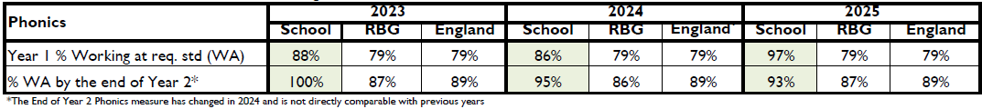

*Table included for the purpose of comparison

KS2

- Disadvantaged group performed well but generally our KS2 data shows an increase in the disadvantage/non-disadvantage attainment gap
- 7/12 of our disadvantaged children were also on the SEN register which may have had an impact (58%)
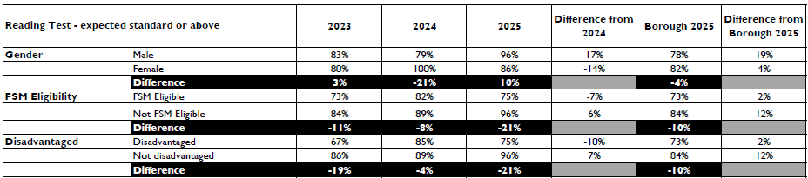
- In reading, our disadvantaged children performed better than the borough’s disadvantaged children at 75% rather than 73%
- Our disadvantage/non-disadvantage group increased significantly to 21%
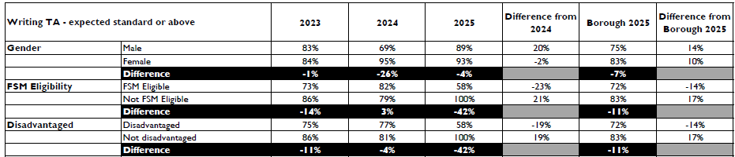
- Writing is the most concerning area with a 42% difference compared to 4% in 2024
- 58% of disadvantaged children were expected standard in writing compared to 72% in the borough
- Of the 5 of our disadvantaged children who did not pass writing, 3 were on the SEN register and one had English as an Additional Language (only joining in Y5)

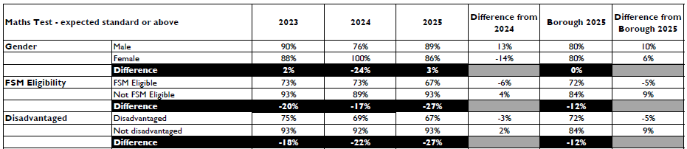
- Maths continues to be an area where disadvantaged children underperform
- 67% of disadvantaged children were expected standard in maths compared to 93% of non-disadvantaged children
R,W,M combined

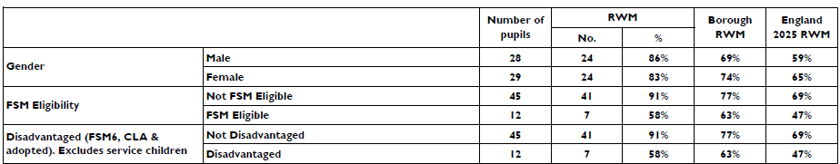

- Children considered disadvantaged in Year 6 achieved 58% in R/W/M
- This was significantly higher than England (47%)
- This was lower than the borough (63%)
- Disadvantaged children are still below non-disadvantaged children’s performance within the school (91%); the gap this year widened to a 33% difference

Conclusions
- Our Y1 phonics results were extremely positive and showed that our strategies for phonics are working
- There were some very strong individual performances amongst our disadvantaged children in KS2 which showed excellent progress and individual success stories
- Individuals within the disadvantaged cohort have made great progress during their time at school
- Despite this, data suggests that the attainment of the school’s disadvantaged pupils in 2024/25 was below our expectations
- Absence and persistent absence among disadvantaged pupils is considerably higher than that of their non-disadvantaged peers
- Improving the attendance of our disadvantaged pupils is a focus

Teacher Data Analysis

- As a guide for our future outcomes and where we need to plug gaps, I have conducted an analysis on teacher assessment of our disadvantaged cohort
- At the end of 2024/25 academic year, I asked for teacher assessment for Reading, Writing and Maths as a guide to what we could expect to see from each year group’s disadvantaged cohort
- At the time, Y1 only had one child registered as disadvantaged and reception had 0; as we get more children registered, the data will change
- Expected or above percentages:
  - Current Y6 – Reading 53%, Writing 47%, Maths 47%
  - Current Y5 – Reading 80%, Writing 60%, Maths 50%
  - Current Y4 – Reading 71%, Writing 57%, Maths 71%
  - Current Y3 – Reading 60%, Writing 40%, Maths 60%
  - 2025 data – Reading 75%, Writing 58%, Maths 67%
- This data shows us that Y3 and Y6 must be target year groups, but every year group must have a focus on their disadvantaged cohort

Externally provided programmes

Please include the names of any non-DfE programmes that you purchased in the previous academic year. This will help the Department for Education identify which ones are popular in England

Programme | Provider
Little Wandle Phonics  White Rose Maths  Mastering Number | Little Wandle  White Rose  NCETM

